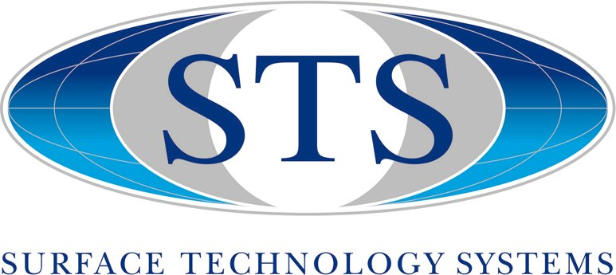
STS Date:
611 Veterans Boulevard, Suite #107 Reference #:
Redwood City, CA 94063
Phone: 650 569 3655
Fax: 650 569 3663

Process Request Form - Etch Technologies

The goal of this document is to learn as much about your application as possible in order to comment accordingly, determine feasibility in an attempt to provide you with a process starting point for you to develop further. Top view & cross sectional drawings of your substrates & structure layers (inclusive of dimensions) are very useful.

Note: STS will require at least 7 days to review this form and provide a response.

NAME:

COMPANY/INSTITUTE:

ADDRESS:

PHONE:
FAX:
E-MAIL:

STS Contact: ANDREW TUCKER

PROCESS: AOE

Once you have completed this form please e-mail it to Andrew Tucker at

E-mail: ajtucker@att.net

Sample Information

Substrate Type & Orientation:
Substrate Size:
# Of Samples:
Customer Identification #’s:
Pre-clean requirements:

- Materials to be Etched

 | Top Layer | Second Layer

Type

Thickness

Uniformity

Deposited By

Doped

Annealed

- Mask Description

Type

Thickness

Side Wall Angle

Exposed Area
Bake Temp. (DUV)

Stepper/Projection

- Underlying Film

Type

Thickness

How Deposited

Topography

- Etch Requirements / Priorities

Priority | Characteristics | Target Value
 | Throughput
 | Etch Rate
 | Uniformity

Selectivity to Mask
(Mask thickness left)
 | Selectivity to Underlayer (Max. removed)
 | Edge Profile
 | CD Loss (Total)

- Sample Treatments

Please detail any other treatments that samples have been conditioned with.

- Comments (Test Criteria etc.) & or Sketch of Structure (Attachments are encouraged)

